South China University of Technology
《Operation System》Experiment Report
Experiment Title： Session 2
Name： 陈宇勋 Student ID： 202230430026
Class： 22计科全英创新班 Group： None
Collaborator： None
Teacher： 钟竞辉
Description
【Objective and Requirement】
Objective：
Solve the Barber Problem and Reader and Writer Problem with code.
Requirement：
For Barber Problem:
Input format:
The first line of input consists of four integers, representing: number of customers n, number of hairdressers, number of chairs, and haircut time (in seconds); In lines 2 to n+1, input the situation of n customers, with 2 variables in each line. The input data is: i-th customer, customer's arrival time.
Output format:
When a customer enters the store and has the opportunity to have a haircut (with a seat or the ability to start directly), print out:
“customer i: there are n customers in front waiting for a haircut”
If the remaining number of chairs is 0, the customer leaves directly and prints out:
“customer i: no more empty chairs, customer leaves”
When the customer finishes their haircut, print out:
"customer i finished haircut"

For Reader and Writer Problem:
Input format:
The first line of input consists of two integers. The first integer indicates the priority order of the readers and writers (1 represents reader priority, 2 represents writer priority), and the second integer indicates the number of readers and writers to be input next. Next, enter 4 variables for each line, with the input data being: process number i, reader/writer, start time of process i execution, and duration of process i. Type enter on the last line to indicate the end.
Output format:
Every time a reader requests to read or write, output:
'writer (/reader) i waiting to write (/read)';
When the reader/writer starts reading and writing, output:
"writer (/reader) i starts to write (/read)";
When the reader/writer completes reading and writing, output:
"writer (/reader) i ends writing (/read)"
【Environment】
Operating System：Linux
Content
【Procedure】
For Barber Problem:
1. Step：
I respectively code barber and customer as a function, then input the data, finally join the barbers and customers into the process and run it. I use three semaphores “mutex”, “wait”, “barber” to ensure the process running logically.
2. Data：
5 1 1 3
1 7
2 3
3 2
4 4
5 10
3. Result：
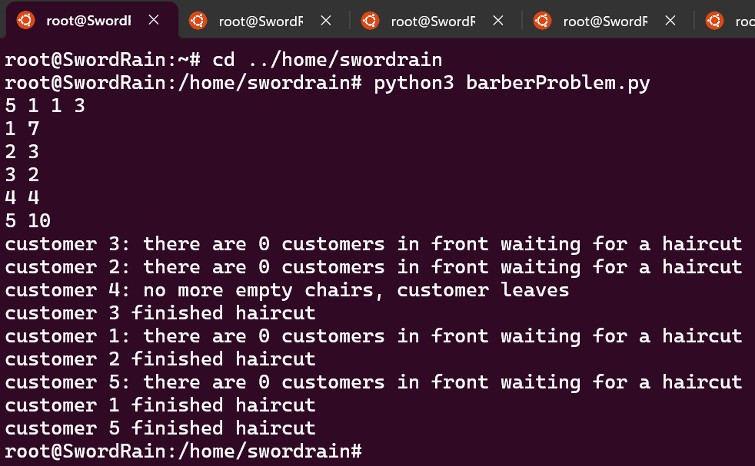
For Reader and Writer Problem:
1. Step：
I respectively code reader and writer as a function, then input the data, finally join the reader and writer into the process and run it. I use three semaphores “mutex”, “xmutex”, “rwlock” to ensure the process running logically.
2. Data：
1 5
1 R 3 5
2 W 4 5
3 R 5 2
4 R 6 5
5 W 9 3
3. Result：
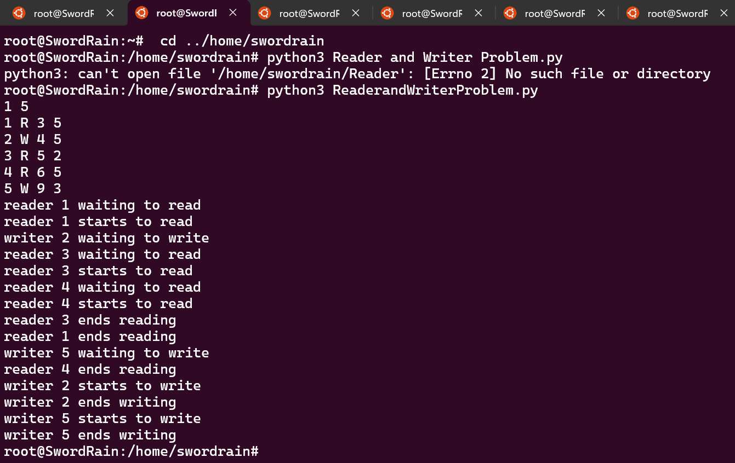
Conclusion
In this experiment, I have learned about how to use semaphore to control the different threading to run reasonably.
Teacher’s Comments and Score
Comment：

Score： Signature：
Date：
Appendix
Task 1: barberProblem.py
import time
import threading

def customer(id, arrive_time):
global emptyChair, custOnChair
time.sleep(arrive_time)
mutex.acquire()
if emptyChair > 0:
print(f"customer {id}: there are {custOnChair} customers in front waiting for a haircut")
emptyChair -= 1
custOnChair += 1
wait.release()
mutex.release()
barber.acquire()
custOnChair -= 1
emptyChair += 1
time.sleep(t)
mutex.acquire()
print(f"customer {id} finished haircut")
mutex.release()
else:
print(f"customer {id}: no more empty chairs, customer leaves")
mutex.release()

def barber_thread():
while True:
wait.acquire()
mutex.acquire()
barber.release()
mutex.release()
time.sleep(t)

n, m, emptyChair, t = map(int, input().split())
custOnChair = 0
arrive_time = [None] * n
for i in range(n):
j, k = map(int, input().split())
arrive_time[j - 1] = k
mutex = threading.Semaphore(1)
wait = threading.Semaphore(0)
barber = threading.Semaphore(0)
barber_thread = threading.Thread(target=barber_thread)
barber_thread.daemon = True
barber_thread.start()
customer_threads = []
for i in range(n):
customer_thread = threading.Thread(target=customer, args=(i + 1, arrive_time[i]))
customer_threads.append(customer_thread)
customer_thread.start()
for customer_thread in customer_threads:
customer_thread.join()
Task 2: ReaderandWriterProblem.py
import time
import threading

def reader(id, arrive_time, consume_time):
global reader_count, waiting_writers
time.sleep(arrive_time)
mutex.acquire()
print(f"reader {id} waiting to read")
reader_count += 1
if reader_count == 1:
rwlock.acquire()
mutex.release()
print(f"reader {id} starts to read")
time.sleep(consume_time)
print(f"reader {id} ends reading")
mutex.acquire()
reader_count -= 1
if reader_count == 0:
rwlock.release()
mutex.release()

def writer(id, arrive_time, consume_time):
global waiting_writers
time.sleep(arrive_time)
print(f"writer {id} waiting to write")
if priority == 1:
mutex.acquire()
waiting_writers += 1
mutex.release()
rwlock.acquire()
print(f"writer {id} starts to write")
time.sleep(consume_time)
print(f"writer {id} ends writing")
rwlock.release()
if priority == 1:
mutex.acquire()
waiting_writers -= 1
mutex.release()

priority, n = map(int, input().split())
info = [None] * n
for _ in range(n):
number, action, arrive_time, consume_time = input().split()
number = int(number)
arrive_time = int(arrive_time)
consume_time = int(consume_time)
info[number - 1] = (action, arrive_time, consume_time)
mutex = threading.Semaphore(1)
wmutex = threading.Semaphore(1)
reader_count = 0
read_wait = threading.Semaphore(0)
write_wait = threading.Semaphore(0)
rwlock = threading.Semaphore(1)
waiting_writers = 0
threads = []
for i, (action, arrive_time, consume_time) in enumerate(info):
if action == 'R':
t = threading.Thread(target=reader, args=(i + 1, arrive_time, consume_time))
else:
t = threading.Thread(target=writer, args=(i + 1, arrive_time, consume_time))
threads.append(t)
for t in threads:
t.start()
for t in threads:
t.join()

